Update on IATO Activities (Saturday 16th July to Saturday 30th July 2022)
Dear Members
Greetings
Please find appended relevant activities of our association for the period (Saturday 16th July to Saturday 30th July 2022)
Segments covered are
- Webinars/ Panel Discussions/Circulars/Meetings/Chapter news
- Media Coverage
- Chapter News
Request your feedback to further the content of our weekly report.

1. Webinars/ Panel Discussions/Circulars/Meetings
Segment 2 update sequence by date:18,20,27,29 July
Monday 18th July
- IATO Extra Ordinary General Meeting on 18th July 2022 at The Park Hotel, New Delhi at 1030 hours
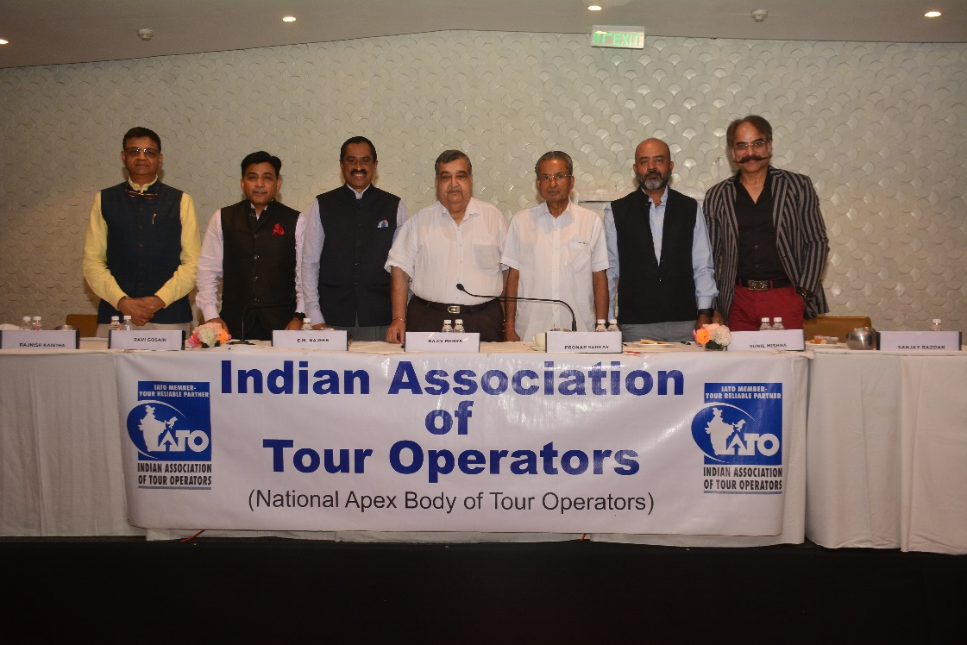

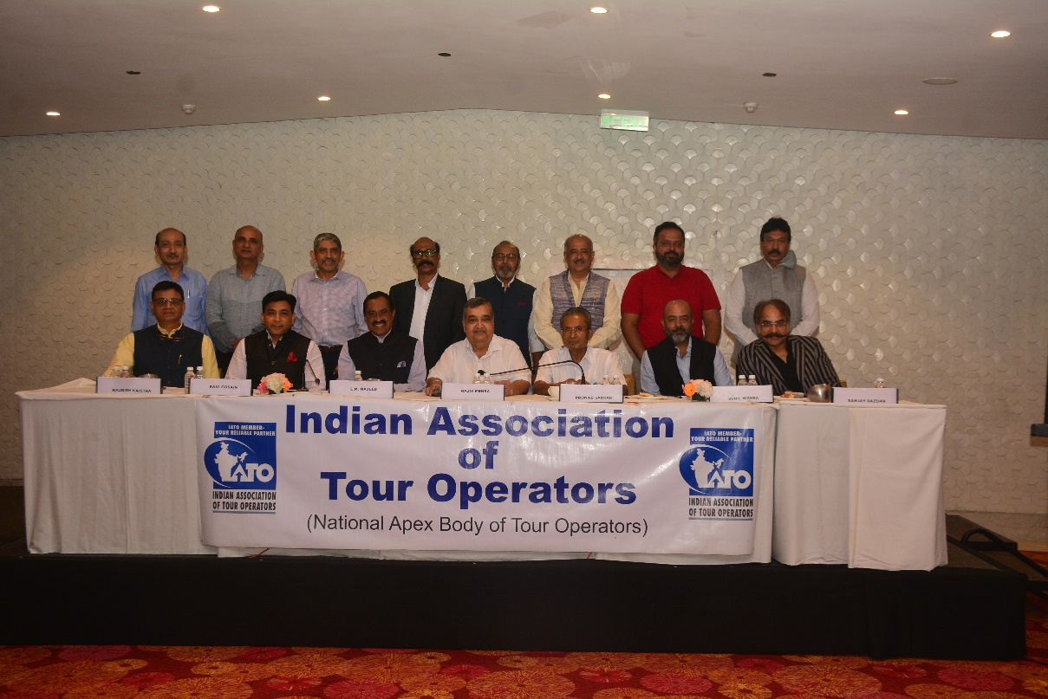
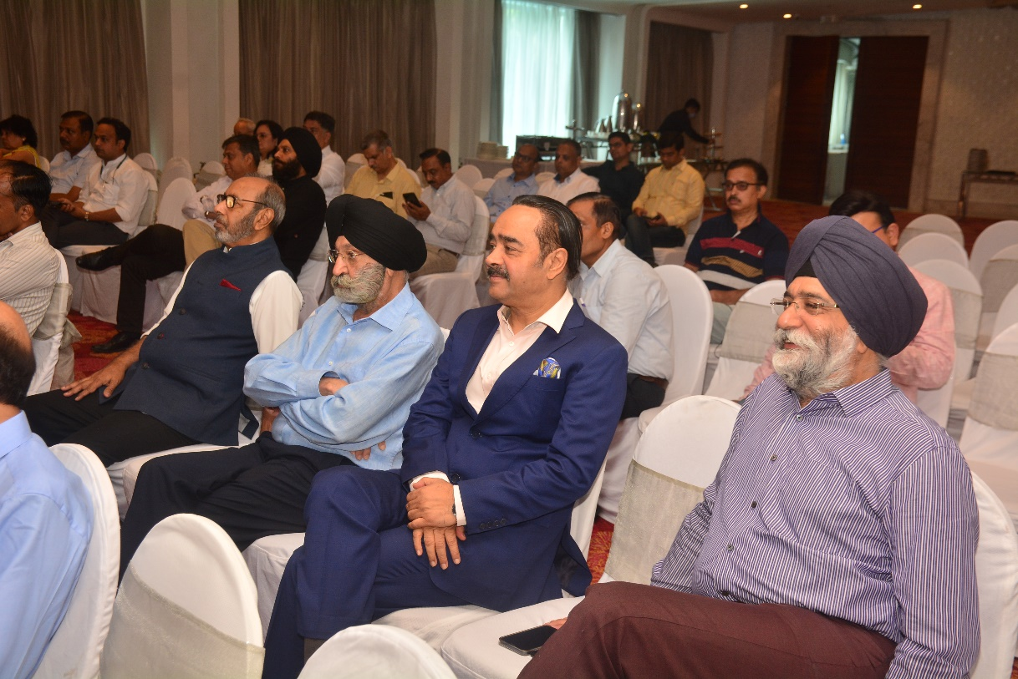
Wednesday 20th July
- All Active Members were informed on the Joining Link for Incredible India Reconnect 2022 (Virtual Road Show) for Italy on Tuesday, the 26th July 2022 at 3.30 pm IST
Wednesday, 27th July
- All Active Members were informed on TPCI's Industry Delegation to Australia for the Travel & Hospitality Sector
- All Active Members were informed on the Invitation for NAMASTE VIETNAM Festival from 16 - 21 August, 2022

Friday 29th July
- All Active Members were informed on the Joining Link for Incredible India Reconnect 2022 (Virtual Road Show): Portugal Edition on Tuesday, the 2nd August 2022 at 4 pm IST
2.Media Coverage
Segment 3 update sequence by date:16,17,19,20,22,25,27,28 July
Saturday 16th July
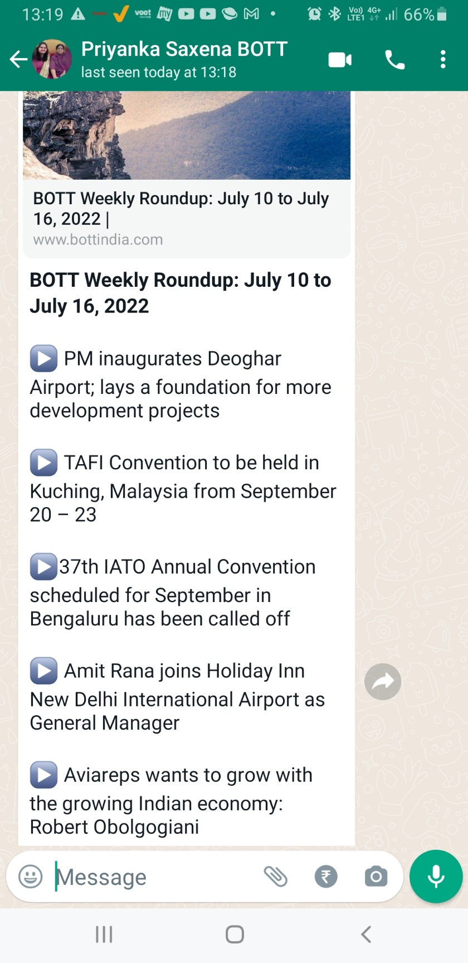

Sunday 17th July
- Mr. Ravi Gosain on NDTV channel on Air Safety issues
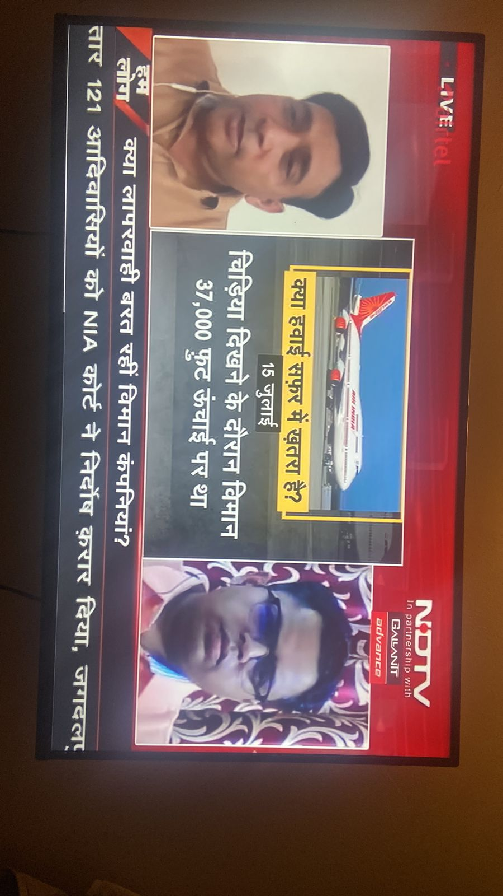
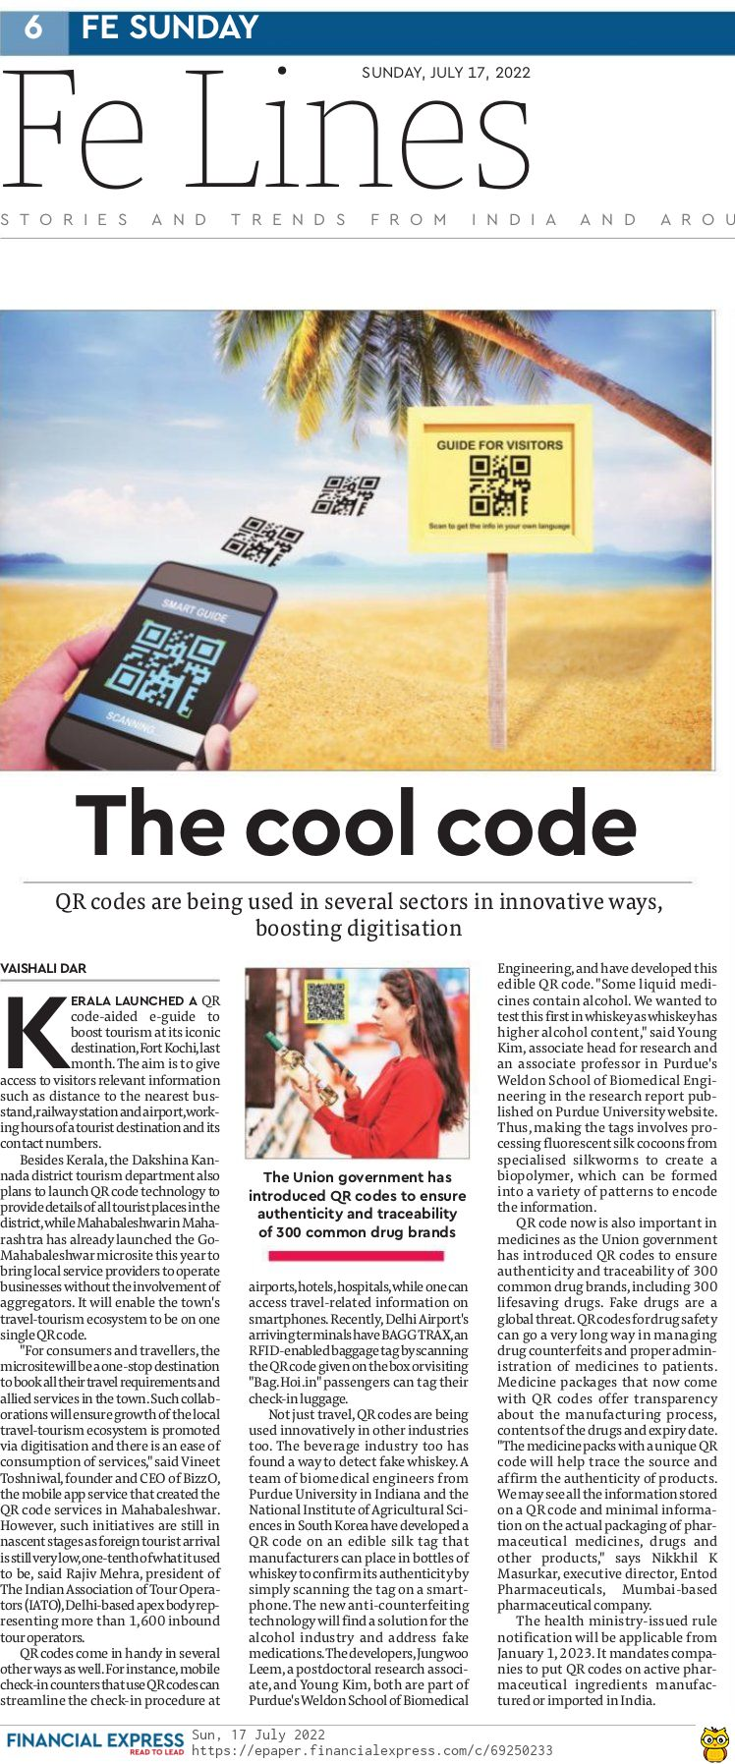

Tuesday 19th July
- IATO General Body unanimously approves amendments in its MOA and rules & regulations
Tourism Industry: IATO General Body unanimously approves amendments in its MOA and rules & regulations, ET TravelWorld News, ET TravelWorld (indiatimes.com)

Wednesday 20th July
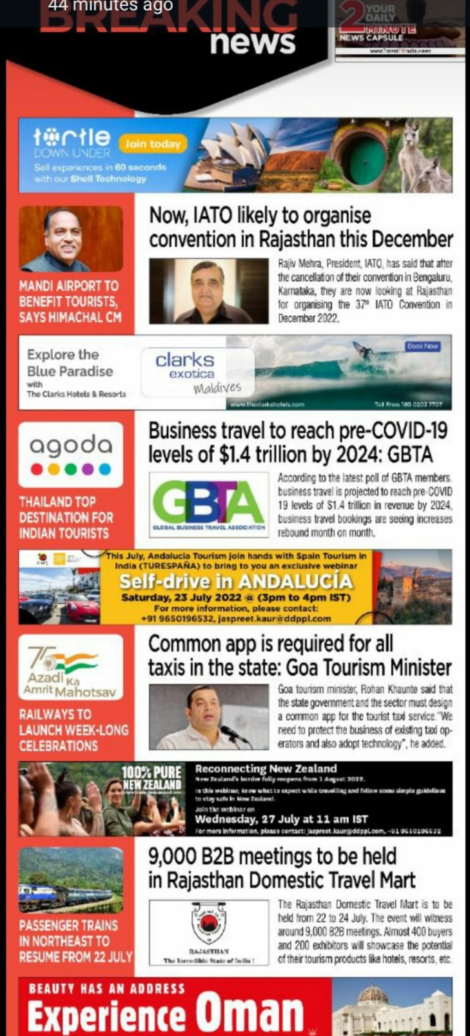

- President talks about the amendments in the IATO Memorandum of Association
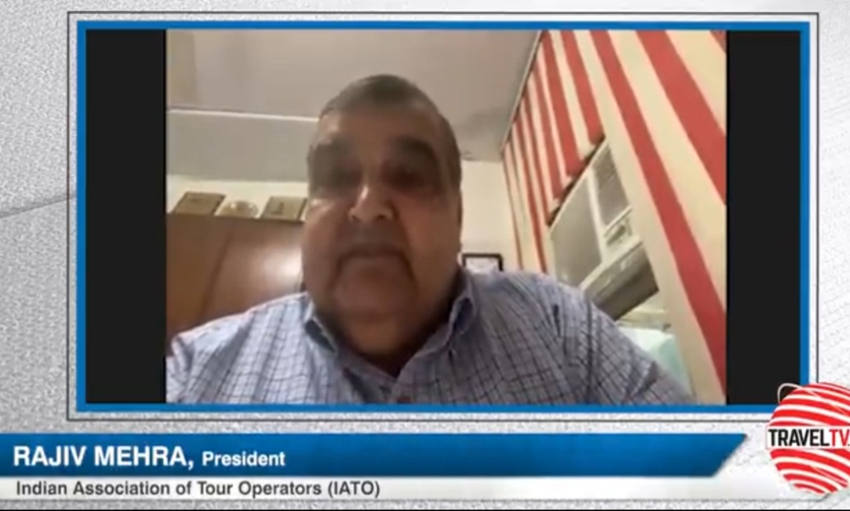

Friday 22nd July
- IATO-expresses-its-sincere-thanks-and-gratitude-to-the-finance-minister-and-gst-council
https://www.travelturtle.world/news/trade-report/iato-expresses-its-sincere-thanks-and-gratitude-to-the-finance-minister-and-gst-council/

- President talks about the proposed IATO Convention in Rajasthan
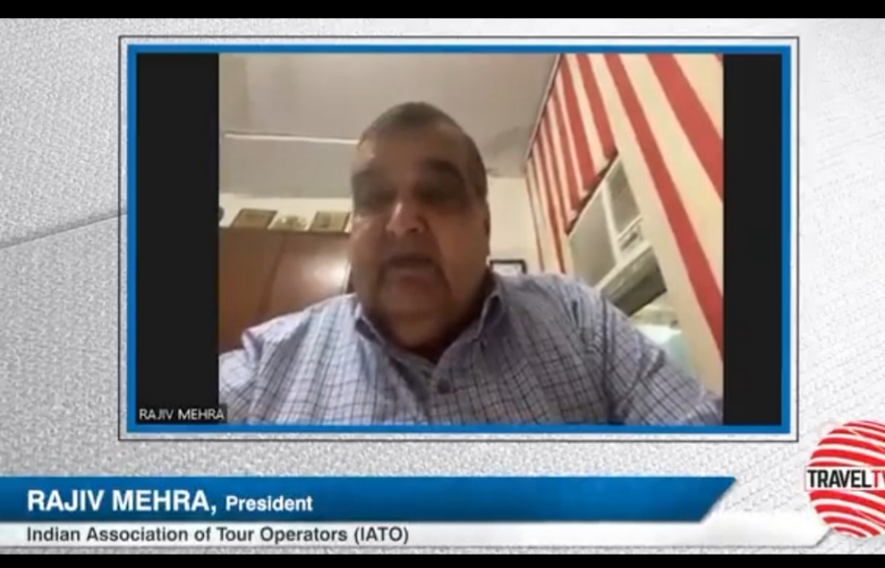

Monday, 25th July
- Rajasthan to Host IATO’s 37th Annual Convention In December: Tourism Secretary, Rajasthan
https://www.travelbizmonitor.com/rajasthan-to-host-iatos-37th-annual-convention-in-december-rajasthans-tourism-secretary/
Wednesday, 27th July
- Vice President IATO interacting with the Media at the Rajasthan Domestic Travel Mart
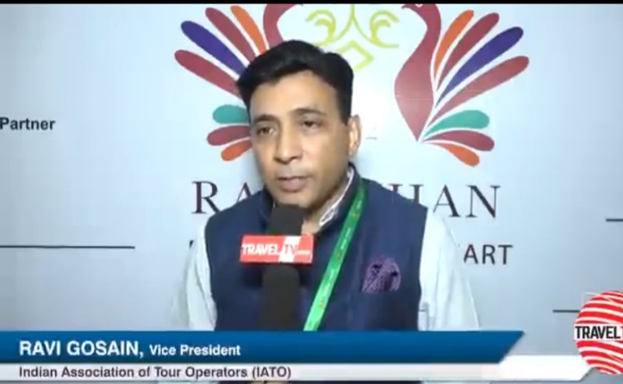
Thursday 28th July

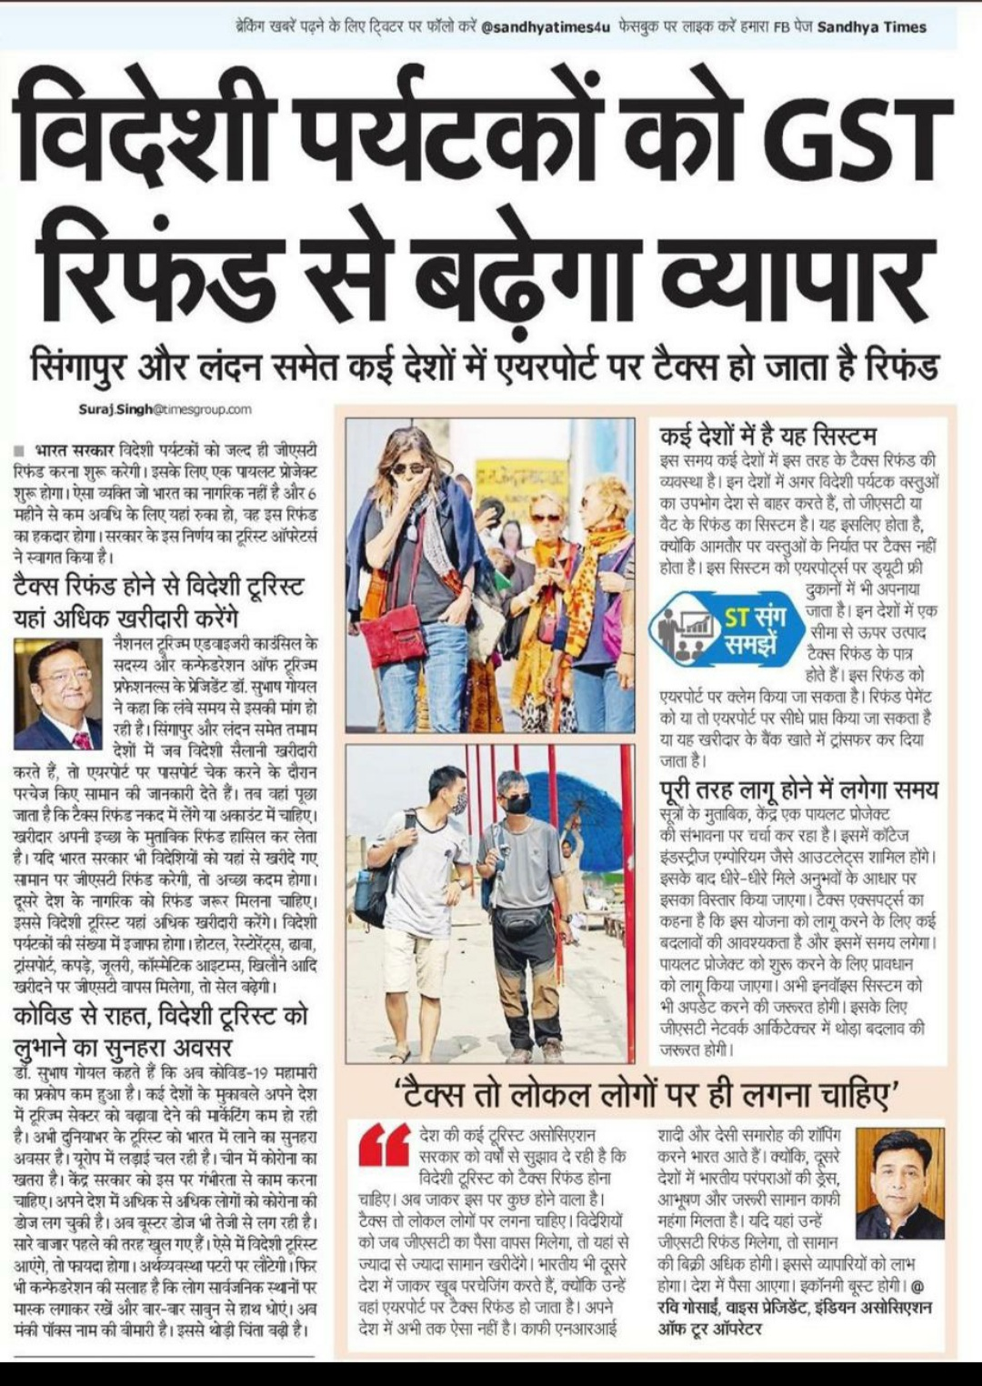

- Chapter News
Segment 4 update sequence by date:16, July
Saturday 16th July
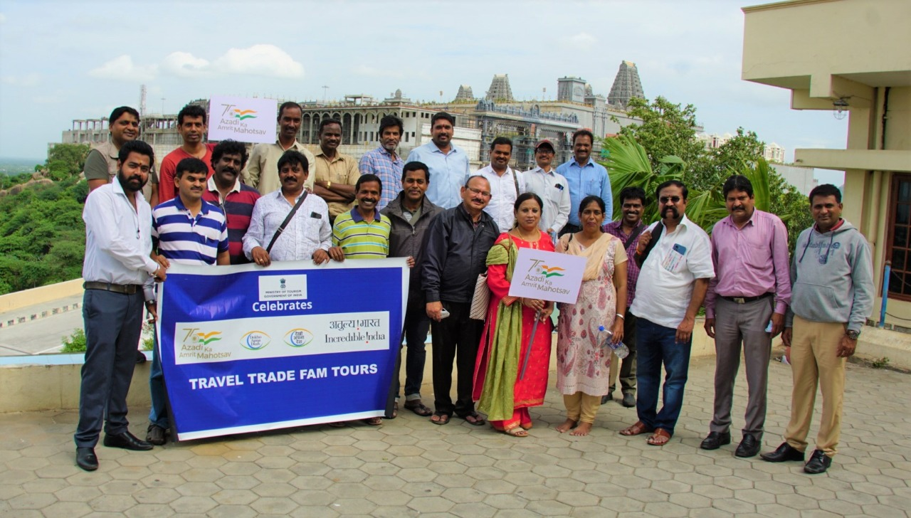
- 15.AUG.22
(IATO TS&AP chapter, India Tourism, Hyderabad)
conducted the FAM / Study tour to YADADRI
(Rs.2000 crores reconstructed Hindu Temple, 75 kms from Hydeabad)

